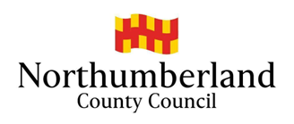
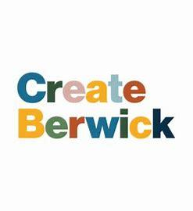


BRIEF for Create Your Future
Youth Training
CCZ Create Berwick

Application Form for Creative Businesses: Create Berwick Youth Training Fund

Section 1: Applicant Information
- Business/Organization Name:
- Contact Person:
- Position/Role:
- Email Address:
- Phone Number:
- Business Address:
- Website (if applicable):

Section 2: Business Overview
- Describe your business/organization and its role in the creative and cultural sector.

- How long has your business/organization been operating?
- What types of creative or cultural activities do you specialize in?

- Have you previously worked on youth training or similar projects? If yes, please provide details.

Section 3: Project Proposal
- Proposed Project Title:
- Provide an overview of your proposed project, including how it aligns with the goals of the Create Berwick Youth Training Fund.

- How many young people will participate in the project?

- What specific work experience opportunities will you provide?

- How will you ensure the safety and well-being of young participants (e.g., safeguarding policies, supervision)?

Section 4: Project Implementation
- Provide a timeline for your project, including key milestones (e.g., recruitment, work placements, evaluations).

- Describe how you will manage and supervise the young participants during the project.

- What support or resources will you require from the Create Berwick team?

- Explain how you will evaluate the project’s success, including the data you will collect.

Section 5: Budget
- Provide a detailed budget breakdown for the project (e.g., participant fees, travel expenses, materials).

- I Confirm the total funding amount requested is within the grant limit (£5,000 maximum, inclusive of VAT): YES/NO

- Will you be using additional funds from other sources? If yes, please specify.

Section 6: Declarations
- Do you agree to comply with all statutory and legal requirements, including safeguarding and GDPR?
☑ Yes
☒ No
- Do you confirm that all promotional materials will acknowledge receipt of investment and include the required logos?
☑ Yes
☒ No
- Do you consent to providing progress reports and a final evaluation to the Create Berwick team?
☑ Yes
☒ No
Signature:
Name:
Date:

Submission Instructions:
Please submit your completed application form by email to:
Darren Holleywell, CCZ Project Officer
Email: darren.holleywell@northumberland.gov.uk
Deadline for Submission: Friday 1st May 2026
For any questions or further information, please contact Darren Holleywell at the above email address.

Please submit your response to Darren Holleywell, CCZ Project Officer
darren.holleywell@northumberland.gov.uk

